6.29: a) The magnitude of the force is proportional to the magnitude of the extension or compression;
b) There are many equivalent ways to do the necessary algebra. One way is to note that to stretch the spring the original 0.050 m requires 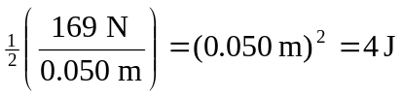, so that stretching 0.015 m requires 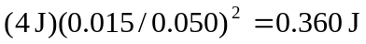 and compressing 0.020 m requires 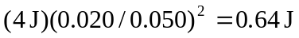. Another is to find the spring constant , from which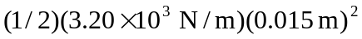 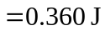and .

